(Approx. 1751 words)

Not Another Sunset!
By Greg Skalka, President, Under the Computer Hood User Group
Drive Light Newsletter
www.uchug.org
president (at) uchug.org

I have seen the sun set on a lot of technology. As tech improvements are made and new innovations come to market to brighten our days, the old devices, systems, and ways of doing things often slowly pass over the horizon and out of sight.

In most cases this is a good thing, bringing many benefits, but there are rarely any downsides, however minor. With a lot of innovations, there can still be some advantages to older ways. Young people today don’t know what it is like to get up from the couch, walk to the TV and turn a knob to change the channel, yet with all that convenience, the remote control can contribute to a sedentary lifestyle. Another thing many don’t remember is having to manually defrost a freezer. Self-defrosting technology saves labor but uses more energy. Automatic transmissions in automobiles made driving easier for everyone but provided poorer mileage until the technology improved. Now many automatic transmissions are manuals with a computer doing the shifting, and it is hard to find a new vehicle with a true manual transmission. A true manual can still be an advantage, however, since when so few today know how to operate them, they are less likely to be stolen or carjacked. A lot of tech innovations improve our lives in almost all aspects, and there seems little reason to retain the old ways.

Computer technology has improved greatly over 40 years. It would be hard to argue that we would be better off today with no Internet and non-portable devices controlled through a text interface or rows of switches, with large monochrome displays that can’t show graphics. All the changes we’ve seen, from the DOS command line prompt through ten or more versions of Windows, all the versions of Apple products, from the stationary desktop through laptops, Chromebooks, tablets, smartphones, and watches, have meant that a lot of products have seen the sun set on them over the years. In most cases, we run enthusiastically towards the rising sun of new products and capabilities. In a few cases, though, it seems major tech players want to push our still useful and valued technology off a western cliff into the abyss of obscurity before we are willing to part with it, all in the interest of ringing up new sales.

I live in the Wintel (Windows-Intel) world and have seen many products and operating system sunsets. DOS was revolutionary, but Windows graphics and mouse use made leaving it easy. Windows XP was a great OS; I’m writing this on a 15-year-old PC that still runs fine (without an Internet connection), with an early version of Microsoft Word that has all I really need. MS Office is one case where I feel Microsoft has been adding “features” and changing versions primarily to squeeze more money out of users. There have been some nice feature improvements over the years, but a lot of the recent changes have been to the user interface, which I feel was just fine as it was. I’m tired of companies that feel they need to change the look and feel of their software to justify new versions and fees. I especially don’t care for the idea of “subscription” software (like Office 365), where I feel I’ve just become a revenue stream to some company.

I know some will say I should perhaps switch to Linux, or at least to open-source (and free) office productivity software, but I unfortunately still live in a working world, where I must use my employer’s MS OS and Office

I prefer not to cloud my sadly-limited mind with having to be fluent in multiple ways of doing things. I have the utmost respect for multi-lingual people, as I have really only ever spoken English, and I often don’t feel I've mastered the one language.

I had a good run with Windows 7 and was sad to have to plan last year for its January 2020 security sunset. A year ago, my wife and I were running three Win7 computers (a desktop and two laptops), three Chrome OS devices (two Chromebooks and a Chromebit), a Win10 computer I hardly used, a couple of tablets, an Android Smartphone and an iPhone. I’m still transitioning to Windows 10; while my wife is happy on her new Win10 desktop, I’m still setting up the new Win10 laptop I bought myself. I try to be good and use my old Win10 computer, but like an unmotivated dieter, I still briefly cheat from time to time and reconnect the network cable on my old Win7 laptop.

I’ve come to terms with Windows 10, having had to use it at work extensively. The Win7 security end-of-life deadline turned out to be a boon for Microsoft and computer makers, as least in regards to my family, It caused me to buy two new desktops (I bought my mom one as well) and a laptop I might not otherwise have been in the market for. It is nice to have new, faster and better equipment, but I resent being forced into things by the deadlines of others.

While I grudgingly use Microsoft’s products, I also chose devices running Google’s Chrome OS to add to my tech stable. I bought my first Chromebook, an Acer Chromebook 11, in 2015. The following year, I bought an Acer Chromebit stick computer. Chrome computers are inexpensive (at least the ones I buy are), quick booting, and very portable. They are great for going on the web and for reading and light writing tasks but are too underpowered for much else. I found my Chromebook was great for web browsing, reading the newspaper, and a wonderful travel accessory. I bought a second Chromebook, a Samsung XE501-C13, in a 2018 Black Friday sale simply because I loved my first one so much I wanted to have a spare.
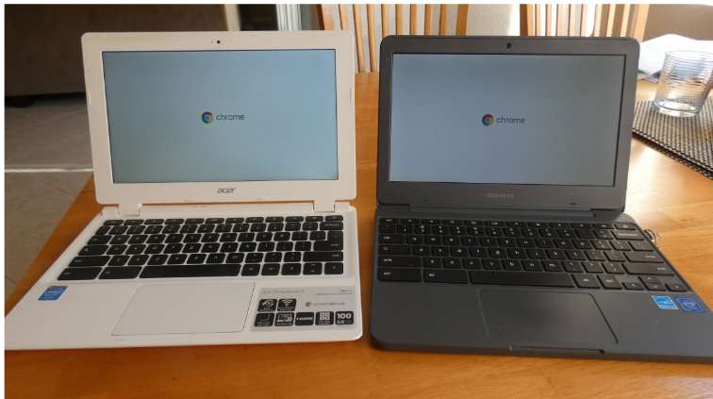

Photo 1: Acer and Samsung Chromebooks

Google started out of the gate with what Microsoft only went to with Windows 10 -forcing automatic OS updates on the user. Google’s Chrome OS updates are small and quick, so you hardly notice they have happened. They have seldom changed the look or features, sticking mostly to security, and I don’t recall hearing of anything breaking as the result of an update. Microsoft of course earned disdain from early Win10 users with forced OS updates happening at inopportune times, taking a long time and breaking existing capabilities.

I use my Chromebooks every day, but myChromebit has seen little use. It is plugged into an HDMI port on the back of our smartTV. I bought it a Bluetooth keyboard and mouse and thought I could surf the web with it like my Chromebooks, but my old eyes have problems with the small text at normal TV viewing distances. It is good for watching YouTube videos, but we don’t do a lot of that. Since COVID, we have been using it every Sunday morning, as our church now broadcasts services on YouTube.

It was on one of these Sunday morning Chromebit viewing sessions that I noticed it had an odd notification: “Updates end November 2020”! With dismay, I started to research this issue. It appears Google has set up a security sunset date for each model of Chrome OS device. This was not well advertised, so users often only find out near the end of their device’s security lifetime.

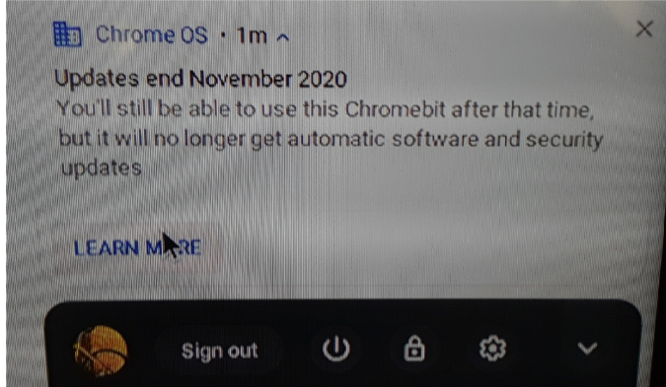
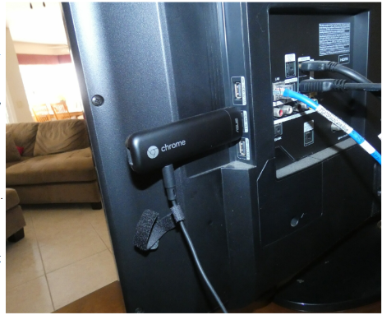
Photo 2: Acer Chromebit stick
computer

Photo 3: Google Sunset Notice

It turns out all Chrome OS devices have a set date beyond which no more updates will be provided, the Auto Update Expiration (AUE) date. The auto part of AUE doesn’t mean much, as I didn’t find any evidence you could manually update the OS after that date either. Google provides information on this at www.google.com/chromebook/older. It is not clear if the manufacturers have any input into this date, but Google certainly appears to, as there is evidence they can change it.

Google emphasizes that this does not prevent the use of the Chrome OS device after the AUE date, but the device will stop receiving Chrome OS and browser updates. These updates include:

- “Security updates, bug fixes, and new features for Chromebooks. Existing features may stop working.”
- “Support for certain apps and extensions that require specific Chrome OS or browser versions.”

I looked up the AUE dates for my three Chrome OS devices. To find the AUE, go to settings, then at the very bottom of the left panel, select “About Chrome OS.” Select “Additional details,” and in the “Update schedule” section the AUE will be shown. I found mine were:

Asus Chromebit - November 2020
Acer Chromebook - September 2021
Samsung Chromebook - June 2022

This means I’ll lose updates on the Chromebit in about 6 months, and I have only a year or two left on my Chromebooks. Now I’m getting that same sinking feeling I get with Microsoft.

I found out a bit more about the AUE from some articles on Chrome enthusiast websites (chromecomputing.com and chromeunboxed.com). According to these articles, Google originally set the AUE dates based on an assumed five-year device life expectancy. The supposed goals were to keep the Chrome OS from having to maintain compatibility with older hardware, keep its reputation as a fast and reliable OS intact and incentivize hardware manufacturers to continue to create new Chrome OS products. They said Google changed to 8+ years of update support for products, starting with those released in 2020. Additionally, Google may be extending the AUE date for recent products to match their new assumed lifespan, so it is possible to find the prior AUE for a product extended.

If Google sticks with the five-year plan for my products, I will be disappointed, as that will make them more restrictive than even Microsoft. I bought the three Win7-installed computers I just retired from use between 2010 and 2012, meaning Microsoft allowed me 8-10 of operation with that OS before “forcing” me to change. I don’t know if I’m careful or just lucky, but I’ve yet to have a computer fail; they always get retired (mostly unwillingly) first.

I guess I’ll be looking for a new Chromebook come the Black Friday sales this year. And now every time I see my Chromebooks, in my mind I’ll be hearing Elton John singing “Don’t Let the Sun Go Down on Me.”

